**Steps for building a django project:**

**os requirements:**

* **Ubuntu 16.0.4**

**Steps :**

* **Open terminal**
* **Update ‘sudo ‘ for latest system packages**

**$ sudo apt-get update**

**make directory:**

* **create a directory for storing all the project files in that directory**

**$ mkdir dev**

**$ cd dev**

**installing pip:**

* **install ‘pip3’ for installing python packages**

**$ sudo apt-get install python3-pip**

**virtual environment:**

* **it is a tool to create isolated python environments. It creates a folder which contains all the necessary packages that a python project would need.**

**$ sudo apt-get install virtualenv**

* **creating a folder with virtual environment**

**$ virtualenv venv**

* **here “venv” is the virtual environment folder name , the folder name is of as your wish**
* **activating the virtual environment**

**$ source venv/bin/activate**

**Mysql database setup:**

**$ sudo apt-get install python3-dev mysql-server libmysqlclient-dev**

**$ pip install mysql-python**

**$ pip install mysql-connector==2.1.6**

**login to mysql:**

* **While installing mysql, copy and save the default password provided by the installer.**

**Installer prompts and show**

* **you the default password. save it and alter root password as below**

**$ mysql -u root -p[root password]**

* **Change the password**

**$ mysql> ALTER USER 'root'@'localhost' IDENTIFIED BY 'MyNewPass';**

* **Create a user**

**$ mysql> CREATE USER 'newuser'@'localhost' IDENTIFIED BY 'password';**

* **Give privileges**

**$ mysql > GRANT ALL PRIVILEGES ON *.* TO 'newuser'@'localhost';**

* **Create database**

**$ mysql > create database databasename;**

**Install django & restframework:**

* **Install Django and Django REST framework into the virtualenv**

**$ pip install django**

**$ pip install djangorestframework**

**Installing atom:**

**$ sudo apt-get install snapd**

**$ snap install atom** --**classic**

**Setting up a new project :**

**$ django-admin startproject projectname**

**Open the project with text editor:**

**$ atom projectname**

* **now in atom you can see the project and app folders with files in it.**

**Move to projects directory:**

**$ cd projectname**

**create an app:**

**$ python manage.py startapp appname**

**Make changes in settings.py file:**

* **in atom go to settings.py file and change the database credentials and also under the installed apps give your app name and rest_framework**

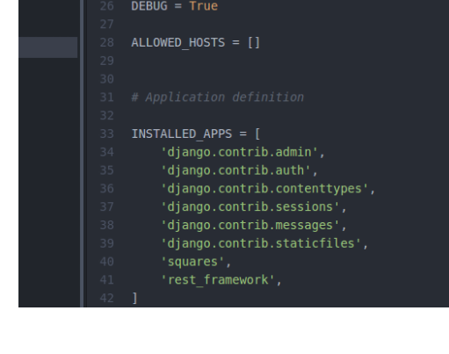

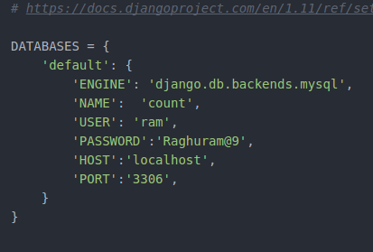

**Create super user:**

* **Super user is created so that the admin the authentication to login to the application page**

**$ python manage.py createsuperuser**

* **While creating superuser it ask you to give username, mail, password**

**Wrting models:**

* **It contains the essential fields and behaviors of the data you're storing. Generally, each model maps to a single database table. Each model is a Python class that.subclasses django.db.models.Model**

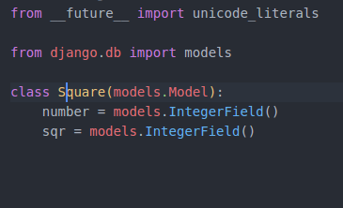

* **After writing models next you have to see the changes and want to migrate them**

**$ python manage.py makemigrations**

* **Now you can see the changes then migrate them**

**$ python manage.py migrate**

* **After migrating the models check the database whether the tables are created or not**

**Admin page:**

* **This administrate Django groups and users, and all registered models in your app. This interface gives you the ability to Create, Read, Update, Delete operations on your registered models.**

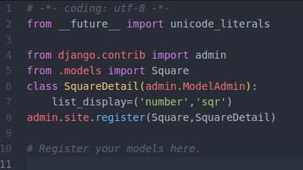

* **Now run the server.**

**$ python manage.py runserver**

* **You will see an link in the terminal open it in browser.**
* **“it’s working” is displayed on the browser because your application is created successfully.**
* **Now add ‘/admin’ at the end of link then it will redirect to the admin page.**

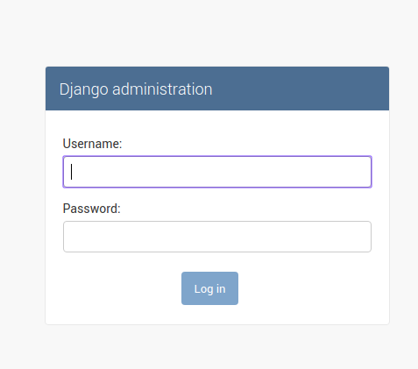

* **Login to the django administration page.**

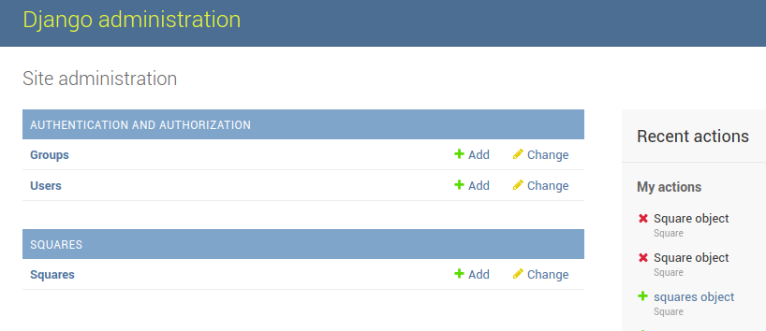

**Writing views:**

* **Your entire logic should be here.**
* **A view function, is simply a Python function that takes a Web request and returns a Web response. Return response can be the HTML contents of a Web page, or a 404 error, or an XML document, or an image . . . or anything.**
* **If you are using djangorestframework the response will be in json format.**
* **The below one is a simple api_view get function.**

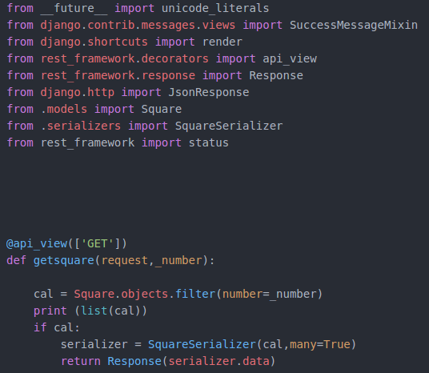

**Serializers:**

* **Django's serialization framework provides a mechanism for translating Django models into other formats.**

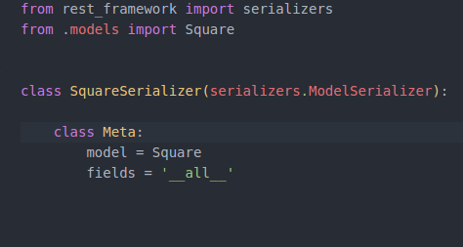

**Urls:**

* **Create urls.py file in the application folder.**
* **Map the application url with project url.**

**Project urls.py**

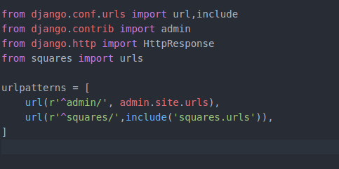

**Application urls.py**

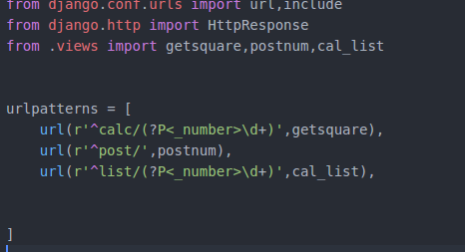

* **Now run the server and check it in the browser.**

**Requirements file:**

* **This file is to save the packages that you have used for this project.**

**$ pip freeze**

* **Now you can see all the packages that you have used for this project like this.**

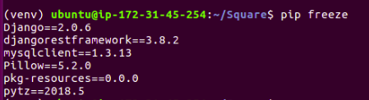

* **You can save it for further use by the following command.**

**$ pip freeze >requirements.txt**

**Pushing code to github:**

* **if you don’t have a github account , Create an account in github. Create a repository for storing and managing the folders.**
* **Create a repository to manage a project or folders at any time.**

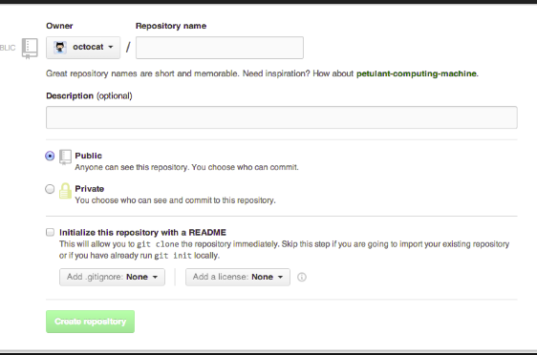

* **Create a .gitignore file in your project folder to ignore the specific files and mention which files you want to ignore. In below screenshot we can see the example “*.pyc” it ignores all .pyc files in your project while commit to github.**

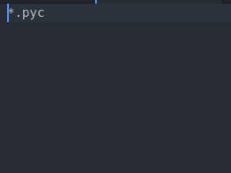

**Then follow the below commands to push the projects to repository:**

* **sudo apt-get install git**
* **git init.**
* **git add “your project name/”.**
* **git status.**
* **git commit -m "message".**
* **git remote add origin “repository root”.**
* **git push -u origin master.**

**Aws Instance:**

* **An EC2 instance is a virtual server in Amazon's Elastic Compute Cloud (EC2) for running applications on the AWS.**

**How to launch a AWS Instance:**

* **Create an account in aws.**
* **After going into console dashboard go to EC2**
* **Click on launch Instance to launch the instance.**

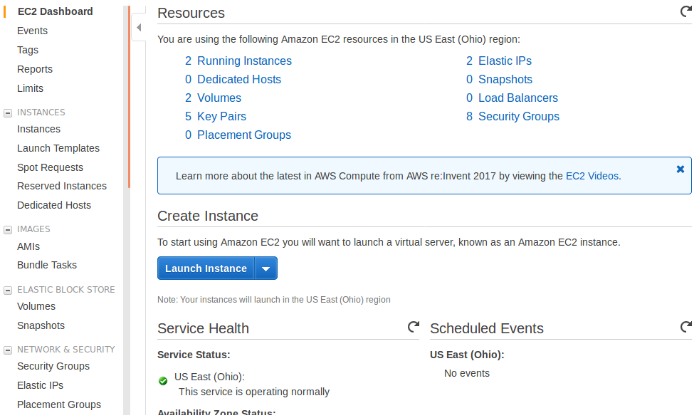

* **Select an ubuntu server 16.04 AMI in below screenshot.**

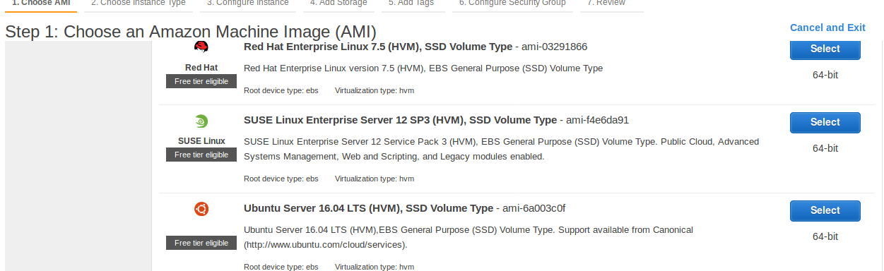

* **Select an instance type t2.micro and Click on review and launch .**

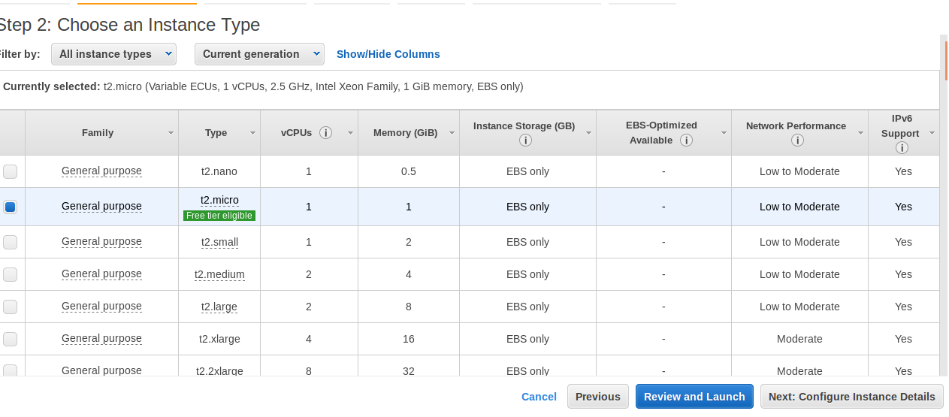

* **Click on launch.**

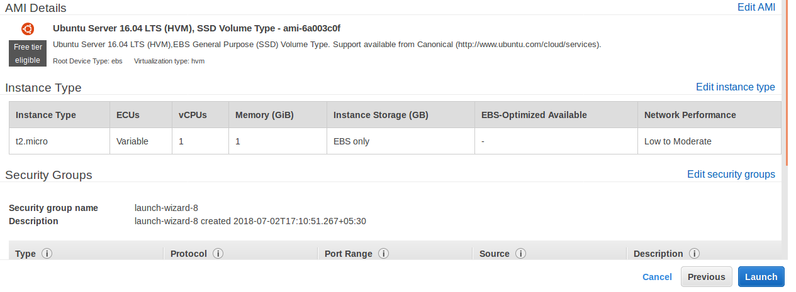

* **Select create a new key pair and give a name in key value pair , and click on**

**download key pair and click on launch to launch the instance.**

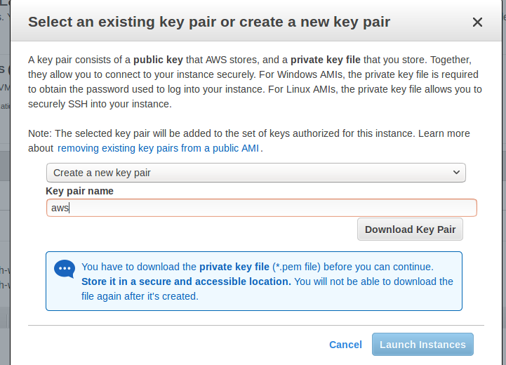

* **select a instance and click on Elastic ip in network&security to set the static ip.**

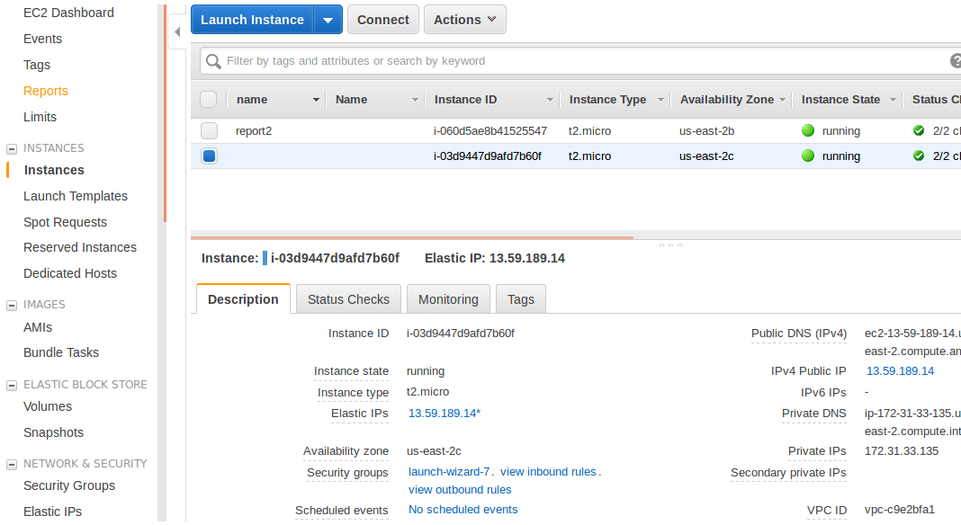

* **click on allocate new address.**

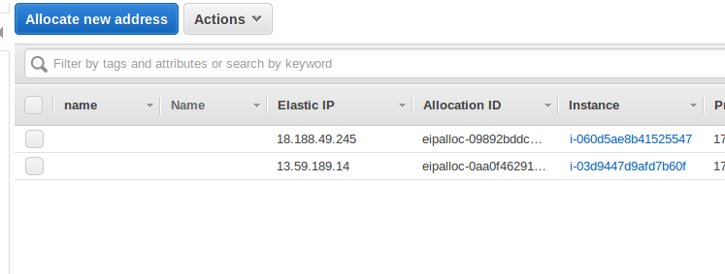

* **Click on allocate.**

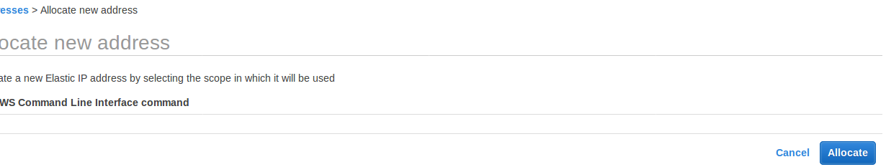

* **Now you can have the elastic ip address.**
* 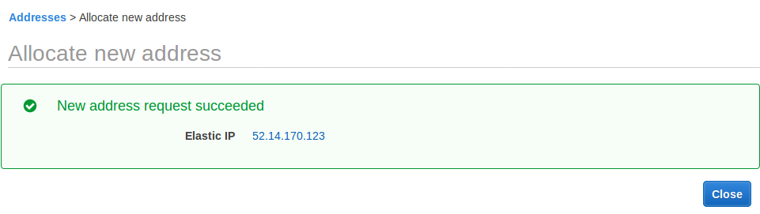**Then you have to sync it to the instance.**

* **Select the ip address , click actions and select associate address.**

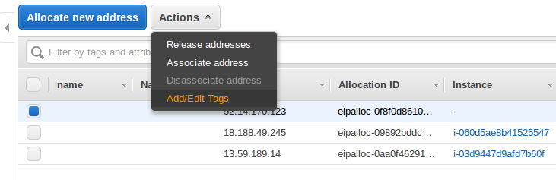

* 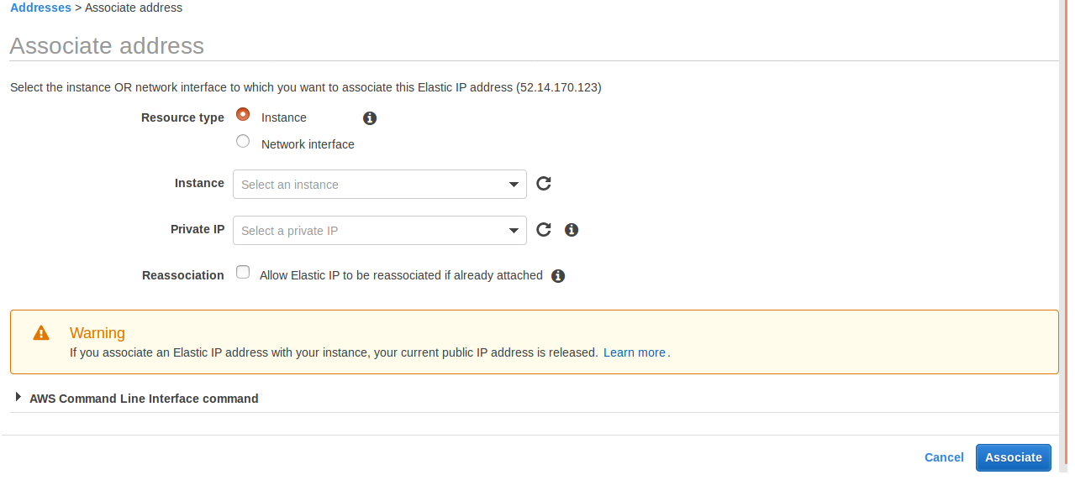 **Select your running instance id and select private ip ,Click on associate.**

* **Check whether the Elastic ip address is associated with instance or not.**

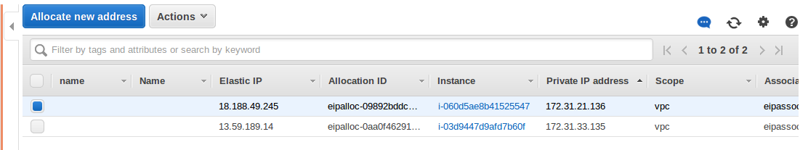

* **Click**
* **Click on instances.**

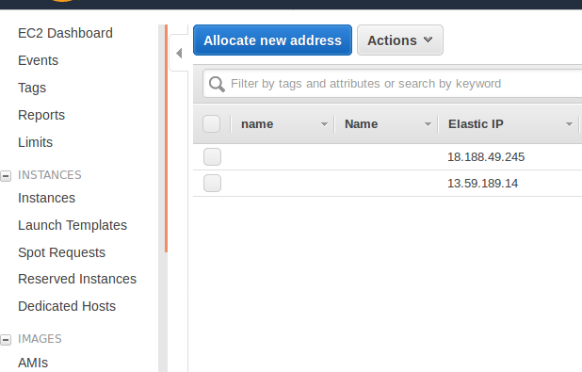

* **Select the instance and click on security groups.**



* **Select your instance group, Click on actions to edit inbound rules.**

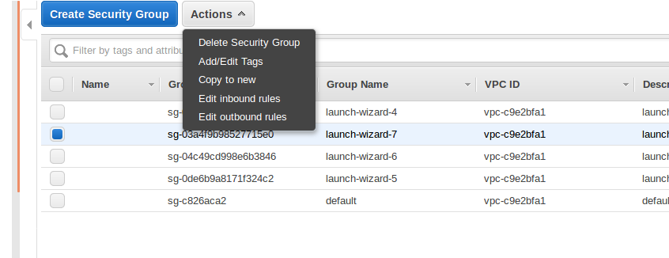

* **By default it has 22 port and remaining port ranges and types you have to set like below mentioned in the screen shot and click on save.**

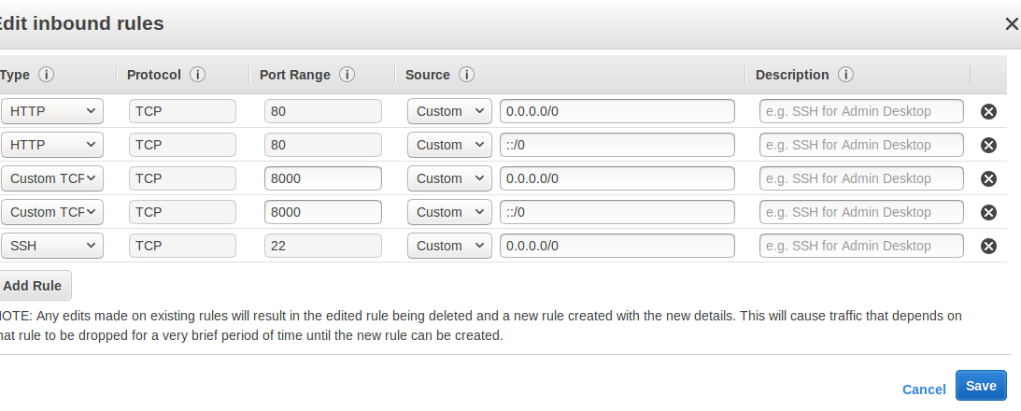

* **Click on instances.**

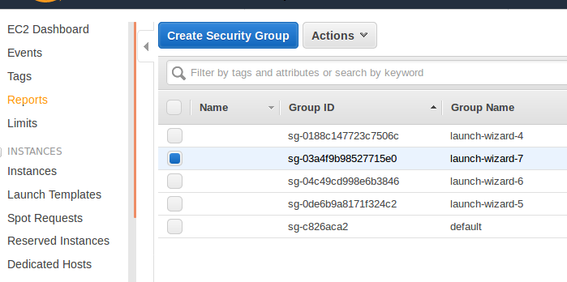

* **Select the instance and click on connect.**

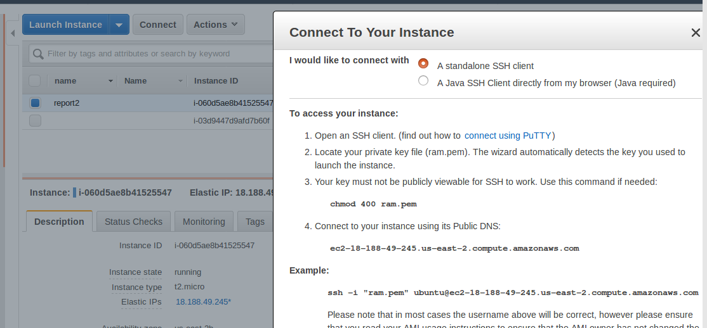

* **You can get the dialogue box like this.**
* **You can connect in your instance in your systems terminal.**

**Steps to connect in terminal:**

* **Open terminal and change the directory to where you downloaded the .pem file .**

**$cd downloads.**

* **Copy and paste the below “ chmod 400 ram.pem ”in terminal.**
* **Next copy the line just below the example its like ssh**

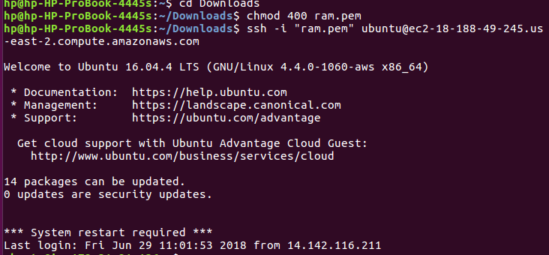

* **Now you are inside the local Ubuntu server**
* **Here once again you have to update sudo**
* **Here again you have install pip3,mysql,virtualenv,python3-dev**
* **Activate your virtualenv**
* **You have to clone the project folder from github now**

**$ git clone [your repository root]**

* **If you have multiple folders in your repository, you have clone only the folder that you wants**

**Cloning a particular folder from git:**

**$ git clone --depth 1 [repository root] [name of the folder]**

**$ cd [folder name]**

**$ git filter-branch --prune-empty --subdirectory-filter [folder name] HEAD**

* **NOTE: No need of square brackets.**
* **Here again you have to do Mysql database setup and login to mysql shell.**
* **Create a database and come out of mysql shell.**
* **Install requirements.txt here.**

**$ pip install –r requirements.txt**

**Edit files:**

* **Here you cannot install atom so you can edit the files in terminal.**

**$ vi [filename]**

* **After opening the file with vi editor press i to make changes after making changes press ‘esc’ and “:wq” to save the file.**

* **Here you have to make changes in settings.py file. In allowed hosts you have to give your ip address and 0.0.0.0 or ‘*’ in single or double quotes. ‘*’ means any one.**
* **if your database credentials are not same then change them in allowed hosts.**
* **Now you have to migrate.**

**$ python manage.py makemigrations.**

**$ python manage.py migrate.**

* **Now your database tables are created.**
* **Create superuser again and insert the data.**
* **Now you can run the server by command.**

**$ python manage.py runserver 0.0.0.0:8000**

* **Now you can check the output in the browser with ip address. And also you can see it in your moblies also.**

**Nginx setup:**

**What is Nginx?**

* **Nginx is one of the most popular webserver for its load balancing, reverse proxy and security. It hosts some of the largest traffic sites on the internet.**

**Installation Steps:**

* **we have to update local package index , so that we can install recent packages.**

**$ sudo apt-get update**

* **install nginx.**

**$ sudo apt-get install nginx**

* **Adjusting the firewall: To configure our firewall to allow acess to the service.**

**$ sudo ufw app list**

* **You should get a listing of the application profiles:**

**Output:**

**Available applications:**

**Nginx Full**

**Nginx HTTP**

**Nginx HTTPS**

**OpenSSH**

* **As you can see, there are three profiles available for Nginx:**
* **Nginx Full: This profile opens both port 80 (normal, unencrypted web traffic) and port 443 (TLS/SSL encrypted traffic)**
* **Nginx HTTP: This profile opens only port 80 (normal, unencrypted web traffic)**
* **Nginx HTTPS: This profile opens only port 443 (TLS/SSL encrypted traffic)**
* **You can enable this by typing:**

**$ sudo ufw allow 'Nginx HTTP'**

* **you can verify the change by seeing the status.**

**$ sudo ufw status**

* **you can see the HTTP traffic allowed.**

**Output:**

**Status: active**

**To Action From**

**-- ------ ----**

**OpenSSH ALLOW Anywhere**

**Nginx HTTP ALLOW Anywhere**

**OpenSSH (v6) ALLOW Anywhere (v6)**

**Nginx HTTP (v6) ALLOW Anywhere (v6)**

* **In case status is inactive follow these steps:**

**$ sudo ufw enable**

**$ sudo ufw status**

* **Check the Nginx service is active or not.**

**$ systemctl status nginx**

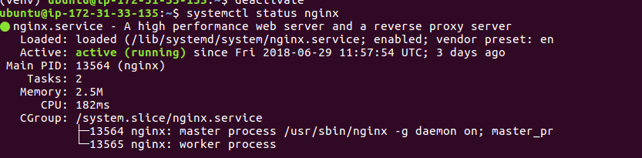

* **When you have your server's IP address or domain, enter it into your browser's address bar:**

[**http://server_domain_or_IP**](http://server_domain_or_IP)

* **You should see the default Nginx landing page, which should look something like this:**

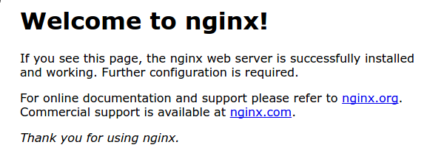

* **This page is simply included with Nginx to show you that the server is running correctly.**

**Uwsgi:**

* **UWSGI: it is an application server which can communicate with applications through interface called wsgi.**

**UWSGI Installion Steps:**

* **install uwsgi by using pip**

**$ sudo -H pip install uwsgi**

* **For instance, we can tell it to serve our first project by typing:**

**$ uwsgi --http :8080 --home /home/ubuntu/venv --chdir /home/ubuntu/projectname -w projectname.wsgi**

* **create a directory to store configure files.**

**$ sudo mkdir -p /etc/uwsgi/sites**

* **create a file for your project and open in a text editor.**

**$ sudo nano /etc/uwsgi/sites/firstsite.ini**

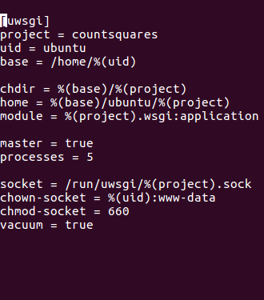

* **in above screenshot you type mention project = “your projectname” , uid = “your system id”**
* **Create a systemd file to automate the uwsgi.**

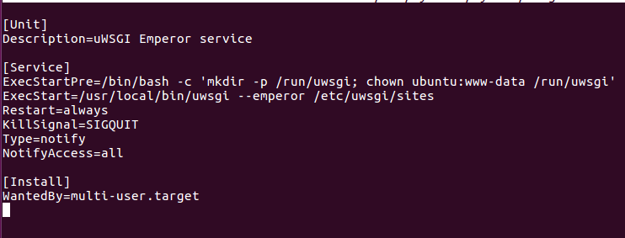 **$ sudo nano /etc/systemd/system/uwsgi.service**

* **Create a server block configuartion file where our project can access.**

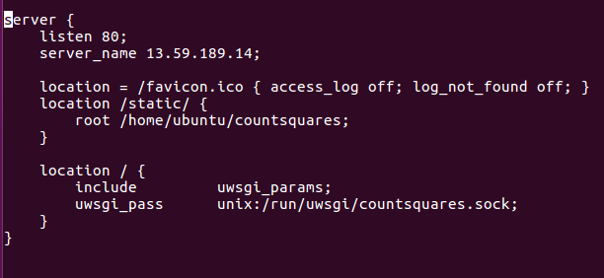

* **link your configuration file to Nginx sites-enabled directory to enable them.**

**$ sudo ln -s /etc/nginx/sites-available/projectname /etc/nginx/sites-enabled**

* **Check the configuration by tying.**

**$ sudo nginx -t**



* **if no errors are detected, you restart your nginx service to load the new configuration.**

**$ sudo systemctl restart nginx**

* **start uwsgi**

**$ sudo systemctl start uwsgi**

* **Let's delete the UFW rule to port 8000 and instead allow access to our Nginx server.**

**$ sudo ufw delete ‘allow 8000’**

**$ sudo ufw allow ‘Nginx Full’**

* **you can enable both of the services to start automatically at boot by typing.**

**$ sudo systemctl enable nginx**

**$ sudo systemctl enable uwsgi**

* **Now you can see the output in browser as nginx is running your server.**

**Refer the below links if you have any doubts in nginx setup:**

1. [**https://www.digitalocean.com/community/tutorials/how-to-serve-django-applications-with-uwsgi-and-nginx-on-ubuntu-16-04**](https://www.digitalocean.com/community/tutorials/how-to-serve-django-applications-with-uwsgi-and-nginx-on-ubuntu-16-04)
2. **https://www.digitalocean.com/community/tutorials/how-to-install-nginx-on-ubuntu-16-04**